Evolution of India's Thriving Startup Ecosystem: From Unicorns to Decacorns

¹Janaki Joshi and ² Dr. Kalpesh Prajapati

Abstract:
India's startup ecosystem has witnessed exponential growth, making it the third largest globally. The Indian entrepreneurial landscape boasts an impressive count of over 1,12,718 startups. These startups are officially recognized by the Department for Promotion of Industry and Internal Trade (DPIIT). They are spread across 763 districts, showcasing the widespread influence of India's startup ecosystem. This research paper endeavors to unravel the intricate evolution of India's startup landscape charting its rapid growth, the rise of unicorns, the pivotal sectors propelling innovation, and the recent emergence of decacorns. By scrutinizing government support mechanisms, funding trends, and the diverse sectors contributing to this vibrant ecosystem, the paper provides valuable insights into the journey and current state of India's dynamic startup environment.
Key words: Startup, unicorn, decacorn, angel investors, incubators, accelerators.

- Introduction
India's startup ecosystem has transformed significantly in recent years, marked by a substantial increase in the number of startups, a surge in funding, and the emergence of numerous unicorns. This paper aims to analyze the key factors driving this evolution and shed light on the current status of India's vibrant startup ecosystem.
The startup ecosystem is a network of innovators, organizations, investors, government bodies, and various support structures working together to foster the creation, growth, and success of startups.It involves both internal and external factors, encompassing individuals, institutions, and processes that contribute to the local entrepreneurial environment.

-------------------------------------------------------------------------------------------------------------------------------¹ PhD Student, Kadi Sarva Vidyalaya University
² Assistant Professor, S.V. Institute of Management Studies, Kadi
India's startup ecosystem has experienced exponential growth in recent years, positioning itself as a global leader in entrepreneurship and innovation. India stands as the 3rd largest startup ecosystem globally, boasting over 112,718 DPIIT-recognized startups spread across 763 districts. The country ranks 2nd in innovation quality among middle-income economies, excelling particularly in scientific publications and university quality. Innovation spans across 56 diverse industrial sectors, with notable representation in IT services, healthcare, education, agriculture, and food & beverages. Notably, 13% of startups operate in IT services, 9% in healthcare and life sciences, 7% in education, and 5% each in agriculture and food & beverages. This extensive network of startups encompasses a wide array of sectors, showcasing India's diversity and innovation.
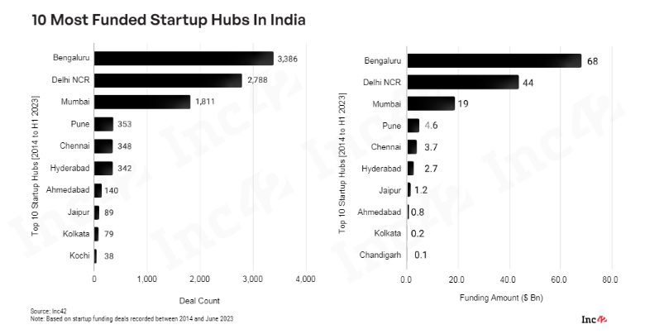
Figure 1 State of Indian Startup Ecosystem Report 2023 by INC 42
- The Rise of Indian Unicorns
The growth trajectory of the Indian startup ecosystem from 2015 to 2022 is staggering, marked by a 15x increase in total funding, a 9x increase in the number of investors, and a 7x increase in the number of incubators. This growth underscores India's position as a hotbed for entrepreneurial activity and innovation.
In India's rapidly evolving economy, the growth of unicorns, or startups valued at over $1 billion, has been remarkable. These companies not only pioneer innovative solutions but also contribute significantly to job creation. Until FY 2016-17, India typically added one unicorn annually. However, in the last four years, starting from FY 2017-18, this rate has surged dramatically, with a staggering 66% year-on-year increase in new unicorn formations. As of October 3rd, 2023, India boasts a total of 111 unicorns, collectively valued at $349.67 billion. Notably, 45 unicorns with a total valuation of $102.30 billion were established in 2021, followed by 22 unicorns with a combined valuation of $29.20 billion in 2022. The year 2023 witnessed the birth of Zepto, marking the sole addition to the unicorn club for that year.

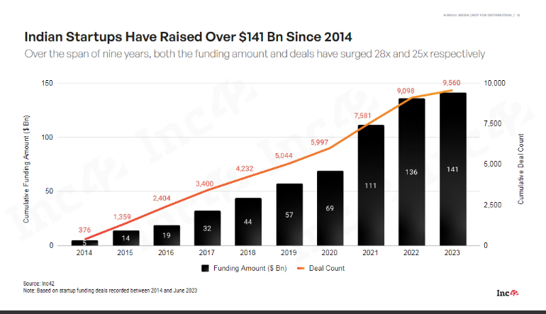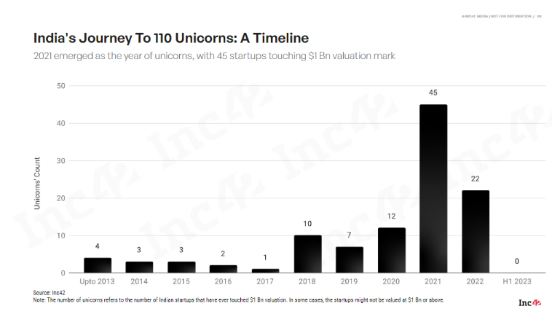
Figure 2 State of Indian Startup Ecosystem Report 2023 by INC 42

- Factors Contributing to the Unicorn Rush (2021)

During the pandemic-induced shift to remote work, India witnessed a surge in digital businesses, contributing to the expansion of its unicorn roster. This growth can be attributed to three key factors: a flourishing digital payments ecosystem, a vast smartphone user base, and the prevalence of digital-first business models. Established tech companies, now household names, have played a pivotal role in fueling India's unicorn boom, leveraging increased smartphone penetration and accelerated digitization across various sectors.
Remarkably, the years 2021, 2020, and 2019 marked peak periods for unicorn births in India, with 45, 11, and 7 unicorns emerging annually, respectively. Despite the socio-economic challenges posed by COVID-19, Indian entrepreneurs demonstrated resilience, contributing not only to economic growth but also to COVID-19 relief efforts. The year 2020 saw the birth of over 10 unicorns, while 2021 earned the moniker "the year of unicorns" with 45 new additions to the ecosystem and several soonicorns waiting in the wings.
Bengaluru stands as India's unicorn capital, hosting the highest number of unicorn headquarters, followed by Delhi (NCR) and Mumbai. While Tier I cities are prominent, India's unicorn ecosystem extends beyond urban centers, permeating even the most remote districts. While traditional sectors like e-commerce, fintech, and supply chain & logistics dominate, unconventional sectors such as content, gaming, hospitality, and data management & analytics are gaining traction.
The journey to unicorn status varies for each startup, with some achieving this milestone in as little as 6 months, while others take up to 26 years. Mensa Brands, for instance, achieved unicorn status in just 6 months in 2021, establishing itself as one of Asia's fastest unicorns.

Furthermore, alongside the growth of the Indian startup ecosystem, there has been a notable emphasis on government efforts to support innovation and entrepreneurship. The regulatory norms and policies have become more favorable and lenient for investors, thereby encouraging increased investment in startups. According to a survey conducted by Inc42 on the state of the Indian startup ecosystem in 2023, which involved over 70 active VC firms in India, it was found that favorable taxation policies, ease of doing business, and a supportive approach towards foreign investment have all contributed to the boost in investment in startups.
Figure 3 State of Indian Startup Ecosystem Report 2023 by INC 42
- Investor Landscape

The resilience of the Indian startup ecosystem is vividly demonstrated in the first half of 2022, as reported by YourStory. During this period, there were 891 funding deals recorded, marking an 82.8% increase compared to the same period in 2021, which had 541 deals. Startups raised over $17 billion in funding, which is 1.8 times higher than the funding raised in the first half of 2021, amounting to $9.4 billion.
Sequoia Capital India emerged as the most active investor, closely followed by Tiger Global Management, Kunal Shah (Founder of CRED), Better Capital, Inflection Point Ventures, LetsVenture, Accel, Blume Ventures, 9Unicorns, and Alpha Wave Global.
Leading sectors attracting funding include FinTech, EdTech, E-commerce, Social Networks, FoodTech, Logistics and Supply Chain, Media and Entertainment, D2C Brands, SaaS, and HealthTech. Notably, FinTech, EdTech, and E-commerce accounted for 19.7%, 9.4%, and 6.2% of total funding, respectively.
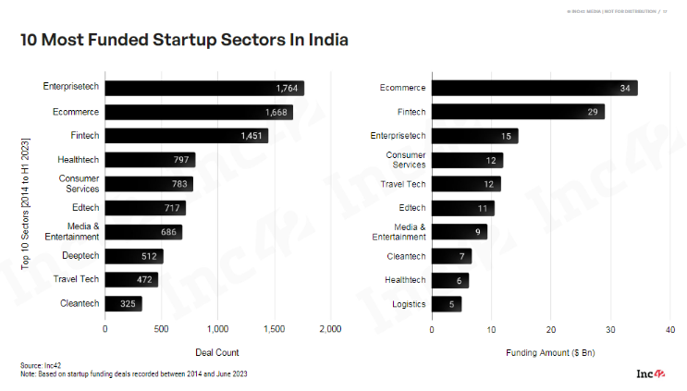
Figure 4 State of Indian Startup Ecosystem Report 2023 by INC 42
There has been a noticeable shift in funding approaches, with startups exploring alternate routes such as crowdfunding, revenue-based financing, venture debt, and bank loans. Startups like Zerodha, which have bootstrapped since their inception, are altering unicorn funding norms by emphasizing independence and revenue generation from the early stages. An unconventional trend observed since the onset of COVID-19 is the entry of startups into the unicorn club without requiring billion-dollar investments.

- There are over 5,500 angel investors, 2,500+ VC/PE entities, 800+ corporate & CVCs, 300+ accelerators & incubators, 300+ family offices, 125+ angel networks & syndicates, and 50+ government entities actively investing in the Indian startup ecosystem.
- The total number of investors is projected to grow from 9.5K+ to 12K+, indicating a robust and growing investment landscape supporting the startup ecosystem in India​.

- Unicorn Sectors Snapshot

Fintech
The Indian fintech sector presents a compelling overview of its startups' trajectory and potential. With a projected total market opportunity expected to reach $2.1 trillion by 2030, the sector is poised for substantial growth and innovation. Additionally, the cumulative value of Unified Payments Interface (UPI) transactions has surged to an impressive $3.6 trillion, showcasing the widespread adoption and utilization of digital payment solutions in the country. Moreover, the total assets under management of mutual funds have reached a significant milestone, amounting to $580 billion, highlighting the increasing investor participation in financial markets. In terms of funding, the sector has attracted substantial investments, with a total of $27 billion raised to fuel further expansion and development. Furthermore, the fintech landscape has witnessed considerable consolidation, with 116 mergers and acquisitions contributing to industry consolidation and synergy. Notably, the sector boasts 23 fintech unicorns, underscoring the emergence of disruptive startups that have achieved significant valuation milestones and are poised to redefine the financial services landscape in India.
Healthcare:
The Indian HealthTech sector emerges as a promising frontier, with a projected total market opportunity exceeding $67 billion by 2030. This robust outlook is further bolstered by the sector's impressive fundraising efforts, having raised over $6 billion through more than 770 deals. Among the various segments within HealthTech, telemedicine stands out as the most lucrative, witnessing significant growth and adoption. Additionally, the sector has experienced notable consolidation, with over 70 mergers and acquisitions contributing to its evolution. Furthermore, the presence of five HealthTech unicorns underscores the sector's potential and allure for investors. Notable unicorns in the HealthTech domain include Innovaccer, Pharmeasy, Tata 1mg, Cure.fit, and Pristyn Care, each making significant strides in revolutionizing healthcare delivery and accessibility in India.
Cleantech:
The Indian startup landscape is vibrant and diverse, with notable players emerging across various sectors. In the realm of electric vehicles (EVs), startups like Altigreen, Ather, and Battery Smart are leading the charge towards sustainable transportation solutions. Additionally, in the climate tech sector, companies such as BATX, Blue Sky Analysis, CHAKR, and CLIMES are pioneering innovative technologies to address environmental challenges. Waste management is another area witnessing significant innovation, with startups like Attero, Blue Planet, Canvaloop, and Cerclex developing solutions for efficient waste disposal and recycling. Moreover, in solar technology, companies like Scapture Solar Energy Limited, Mysun, Sorjan, and Solar Square are harnessing the power of the sun to drive clean energy initiatives. With over 260 active startup investors fueling growth and innovation, the ecosystem has seen substantial funding, surpassing $6 billion raised through 290+ funding deals. Among these investments, the electric vehicle segment stands out as particularly lucrative. Furthermore, the sector has produced two unicorns, reflecting the immense potential and attractiveness of Indian startups in the global market.
Ecommerce
The Indian e-commerce sector presents a compelling outlook, with a projected total market opportunity exceeding $400 billion by 2030. This growth is further fueled by the anticipation of over 500 million e-commerce shoppers in the country by the same year. In terms of funding, the sector has seen substantial investment, totaling $33 billion raised through more than 1,500 deals. Notably, the beauty and personal care segment emerges as the most lucrative, attracting significant attention from investors and consumers alike. The sector has also witnessed notable consolidation, with over 219 mergers and acquisitions contributing to its evolution. Furthermore, the e-commerce landscape boasts an impressive 25 unicorns, underscoring the sector's robust growth trajectory and attractiveness to investors.
In the Business-to-Consumer (B2C) domain, notable startups such as Flipkart, Snapdeal, Paytm Mall, and Firstcry have established themselves as market leaders. In the Business-to-Business (B2B) segment, companies like IndiaMART, Udaan, and Moglix are revolutionizing commerce between businesses. Additionally, in the Direct-to-Consumer (D2C) category, startups like Lenskart, Licious, FreshToHome, and Paperfry are gaining traction with their innovative approaches. For recommerce, platforms such as Cars24, CarDekho, Quikr, Droom, and Spinny are reshaping the pre-owned market. In social commerce, platforms like Meesho, Limeroad, and CityMall are leveraging social networks for retail transactions. Lastly, in the rollups sector, brands like Neso Brand and Upscalio are consolidating smaller businesses to create larger entities with enhanced capabilities and market reach.
Edtech

The Indian education technology (EdTech) sector is poised for significant growth, with a projected total market opportunity exceeding $29 billion by 2030. This optimism is fueled by substantial investment, with over $10 billion raised through 680+ funding deals. Among the various segments within EdTech, K12 education emerges as the most lucrative, attracting considerable attention from investors and stakeholders. The sector has also witnessed notable consolidation, with over 110 mergers and acquisitions contributing to its evolution. Furthermore, the EdTech landscape boasts an impressive 7 unicorns, reflecting the sector's robust growth trajectory and attractiveness to investors.
Notable startups have emerged across different categories within EdTech. In the K12 segment, companies like BYJU's, Vedantu, Physics Wallah, and Cuemath are revolutionizing traditional education methods and content delivery. For test preparation, platforms such as Unacademy, LEAP, and Toppr are providing personalized learning solutions to students. In the EdTech SaaS category, startups like Lead and Techmint are offering innovative software solutions to educational institutions. Moreover, in online certification courses, companies like UpGrad, Eruditus, and Simplilearn are empowering individuals to upskill and advance their careers. For online discovery, platforms such as College Dekho, Edukart, and UrbanPro are facilitating easy access to educational resources and services. Finally, in skill development, startups like Scaler, Newton School, and Coding Ninjas are equipping individuals with the technical skills needed in today's digital economy.
Media & Entertainment
India's digital landscape is witnessing exponential growth, with a staggering 759 million active internet users driving the expansion of various sectors. This growth is further fueled by significant investments, with over $9 billion raised through 650+ funding deals. Among the diverse segments, gaming emerges as the most lucrative, capturing the attention of both investors and consumers alike. Moreover, the sector has experienced substantial consolidation, with over 70 mergers and acquisitions contributing to its evolution. Furthermore, the digital ecosystem boasts an impressive 7 unicorns, reflecting the sector's robust growth trajectory and investor confidence.

Notable unicorns have emerged across different categories within the digital space. In the realm of social media and chat, startups like Betterhalf.ai, Chingari, and ShareChat are redefining social interaction and content sharing. In the digital media category, unicorns like Inc42, Inshorts, and Pratilipi are revolutionizing content creation and distribution. For gaming enthusiasts, platforms such as Dream11, Games24Seven, and Mobile Premier League (MPL) are offering engaging gaming experiences and opportunities. Additionally, in the over-the-top (OTT) streaming category, unicorns like Hoichoi, Disney+ Hotstar, and JioSaavn are providing diverse entertainment options to consumers, further enriching the digital experience for millions across the country.
Enterprisetech
India's small and medium-sized businesses (SMBs) play a crucial role in the country's economy, with a significant presence of over 63 million SMBs. These businesses are increasingly leveraging digital solutions to enhance their operations, contributing to the growth of the startup ecosystem. The sector has seen substantial investment, with over $14 billion raised through 1.6k+ funding deals, reflecting investor confidence in its potential. Among the various segments within the startup landscape, horizontal Software as a Service (SaaS) emerges as the most lucrative, attracting significant funding and attention. The sector has also witnessed notable consolidation, with over 220 mergers and acquisitions contributing to its evolution. Furthermore, India boasts an impressive 22 unicorns in the enterprise tech space, reflecting the sector's maturity and attractiveness to investors.
Notable startups have emerged across different categories within enterprise tech. In horizontal SaaS, companies like AdPushup, Amagi, AppsFlyer, BrowserStack, CleverTap, and CloudSEK are providing innovative solutions to businesses across various industries. Meanwhile, in vertical SaaS, startups such as BestDoc, CareStack, Dukaan, and Innovaccer are catering to specific niche markets, offering tailored solutions to meet the unique needs of their customers. These startups are driving innovation and efficiency in business operations, empowering SMBs to thrive in an increasingly competitive market landscape.

- Next Stage: Going Beyond the Unicorn - The Decacorns

A shift from the age of unicorns to the age of decacorns, A decacorn is company that has attained a valuation of more than $ 10 Bn. In the year 2023 55 companies across countries achieving a valuation of more than $10 Bn globally.
India boasts five decacorns, including Flipkart, BYJU's, Nykaa, and Swiggy, highlighting the country's growing influence in the global startup landscape.

- Geographical Impact
Bengaluru remains the unicorn capital of India, housing the highest number of unicorn headquarters, followed by Delhi (NCR) and Mumbai.
The startup ecosystem is not restricted to Tier I cities, with innovation proliferating across the country.
- Over $41 billion has been raised by startups based in Delhi NCR since 2014.
- The region is home to 8,000+ DPIIT registered startups and 1,500+ funded tech startups.
- The leading sectors include Ecommerce, Enterprise Tech, Fintech, Consumer Services, Media & Entertainment, Edtech, Traveltech, Healthtech, Logistics, and Cleantech.
- This distribution provides insight into the diverse nature of the startup ecosystem in India Enterprisetech, Ecommerce and Fintech leading the way in terms of deal count
- The top emerging hubs outside the major centers are Pune, Chennai, Hyderabad, Ahmedabad, Jaipur, Kolkata, Kochi, Indore, Chandigarh, and Coimbatore.
- These cities have seen significant funding, with Pune leading at $4.6 billion, followed by Chennai at $3.7 billion and Hyderabad at $2.7 billion.
- The list indicates the geographic diversification of the startup ecosystem within India, highlighting the spread of innovation and investment beyond the traditional centers
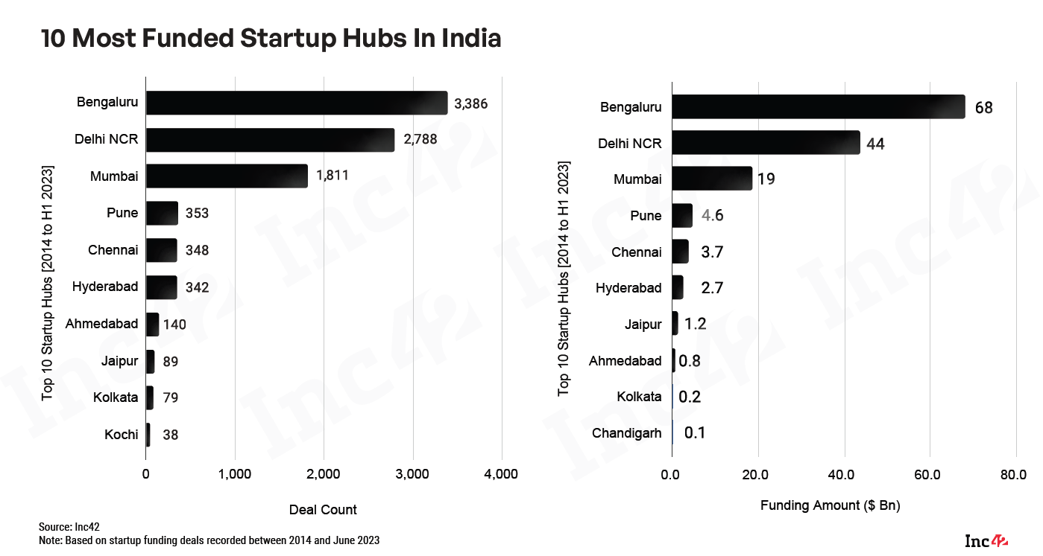
Figure 5 State of Indian Startup Ecosystem Report 2023 by INC 42

- Future Outlook
India's startup ecosystem is poised for continued growth and innovation, with startups transitioning from unicorns to decacorns. Companies like Flipkart, BYJU’s, Nykaa, and Swiggy lead the way, reflecting India's potential as a global powerhouse in the startup landscape. With supportive government policies, technological advancements, and a vibrant entrepreneurial spirit, India is set to solidify its position as a leader in the global startup ecosystem.Notably, the Flipkart acquisition by Walmart for $16 billion stands out as the largest ecommerce acquisition globally.
- Conclusion
India's startup ecosystem's growth is further accentuated by statistics such as the projected 26% annual growth in investor participation, with 3,808 unique investors expected to reach 18,871 by 2023. This surge in investor interest, with 85% of funds focused on Indian startups backed by domestic limited partners, underscores the confidence and allure of the ecosystem.
In essence, India's startup journey exemplifies resilience, adaptability, and innovative prowess, promising to inspire meaningful change on a global scale. With a diverse array of startups spanning various sectors and a thriving investment landscape, India stands poised to shape the future of entrepreneurship and innovation on a global scale.
References:
Report:
- State of Indian Startup Ecosystem Report 2023 by INC 42
- National Report on State Startup Ranking 2022
- Compendium on State Startup Ranking 2022
Website:
- https://www.investindia.gov.in/indian-unicorn-landscape#:~:text=This%20is%20a%20testament%20to,as%20of%2003rd%20October%202023
- https://www.startupindia.gov.in/content/sih/en/reources/market-research.html
- https://www.india-briefing.com/news/investment-outlook-for-indias-startup-ecosystem-in-2023-29731.html/

