AI Driven Retail: A Study on Technology Readiness and its Impact on Consumer Behaviour
¹Dr. Jagriti Mishra, ²Ms. Nisha Punglia, ³Ms. Anjali

ABSTRACT
This research explores the evolving landscape of retail sector with respect to consumer behaviour as influenced by the widespread integration of artificial intelligence (AI) technologies. Specifically focusing on the impact of AI in self-checkout systems and personalized recommendations, the study aims to discern how these technological advancements shape consumer behaviour, with a keen exploration of variations across diverse consumer groups. The research examines the dynamic effects of AI-driven innovationson the shopping experience. In the context of self-checkout systems, the study examines the impact of AI on consumer behaviour, considering factors such as faster checkout times and reduced labour costs. Additionally, this investigation sheds light on the complex interplay between AI technologies and diverse consumer groups, offering a comprehensive understanding of the multifaceted influence of AI on consumer behaviour in the retail domain.The research successfully delineated two distinct consumer segments: those inclined towards technology and those emphasizing human interaction. The survey outcomes revealed a noteworthy dichotomy among customers, with a subset expressing a preference for personalized, human-assisted shopping experiences, while the other contingent favoured features such as self-checkout facilities.

Keywords
Artificial intelligence, Retail, Human, Technology, Consumer Behaviour

Introduction
The global economy relies heavily on the retail industry, which has demonstrated remarkable growth and adaptability. Its capacity to adjust to changing consumer preferences and incorporate technological advancements, including the integration of AI, underscores its resilience and significance in contemporary
society. The transition from traditional brick-and-mortar stores to e-commerce and further to omnichannel
retail serves as evidence of its ability to innovate and stay pertinent in a constantly shifting market landscape.

¹Associate Professor, Department of Fashion Management Studies,NIFT, Gandhinagar
^{2,3}PG Student, Department of Fashion Management Studies,NIFT, Gandhinagar

Various aspects of AI utilization in the retail sector include personalization, inventory management, customer service, pricing strategies, fraud detection, enhanced shopping experiences, and predictive analytics. In the face of today's competitive landscape, retailers confront numerous challenges, encompassing inventory management, customer engagement, supply chain efficiency, fraud prevention, and more. Successfully addressing these challenges typically demands a combination of technological innovation, strategic planning, and a profound understanding of consumer behaviour and market dynamics.

The most important aspect of AI is human acceptance and the dynamics involved. Since the beginning of times retail has primarily remained very human oriented. With changing times, like most of the aspects of human existence, technology has also slowly grown in the field of retail.
This paper explores consumer behavior with reference to AI features in retail stores and examines how the acceptance of such features varies among diverse consumer groups.

Literature Review
Artificial Intelligence (AI) has emerged as a transformative force in the retail industry, offering unprecedented opportunities for innovation and efficiency. The applications of AI in retail are diverse, ranging from enhancing customer experiences to optimizing supply chain management. AI has revolutionized customer interactions in retail through personalized recommendations and improved shopping experiences. Machine learning algorithms analyse customer data to understand preferences, enabling retailers to tailor product recommendations leading to increased customer satisfaction thereby contributing to higher conversion rates and customer loyalty (Li & Zhang, 2018).

AI-driven forecasting models leverage historical data, external factors, and real-time analytics to predict demand accurately thereby leading to effective inventory management. It has been observed that AI-based inventory optimization reduces costs, minimizes stock-outs, and improves overall supply chain efficiency (Chen, Song, Wang & Zhang, 2019).

AI algorithms play a crucial role in enhancing the security of retail operations through the detection of fraudulent activities. By conducting real-time analyses of transactions and behavioral patterns, these algorithms facilitate the prompt identification of anomalies. Research highlights the effectiveness of AI in preventing fraudulent transactions, safeguarding both retailers and consumers (Smith, Wright, & Dhillon, 2020).

AI facilitates end-to-end visibility and optimization in the supply chain. Integration of AI-powered analytics enables retailers to streamline logistics, reduce lead times, and enhance overall operational efficiency. According to research, AI-driven supply chain solutions improve agility and responsiveness to market dynamics (Wang & Gunasekaran 2017).

The deployment of virtual assistants and chatbots powered by natural language processing has redefined customer service in retail. Chatbots handle routine queries, provide product information, and facilitate seamless online transactions . Research emphasizes the role of AI-driven virtual assistants in enhancing customer engagement (Lee, Kim & Lee, Y., 2021).

From inventory management to planogram automation, customer service to demand forecasting, retailers can enhance their operations using AI-powered tools across various aspects of their businesses. Visual merchandising, a fundamental component of retail where the appeal of products is crucial, remains significant (Mondol, Salman, Rahid & Karim, 2021). A recent U.S. market survey revealed that end users are not ready to entirely abandon physical stores. In fact, 34% of respondents expressed dissatisfaction with the delivery time of e-commerce products, and 25% were unwilling to pay perceived high shipping fees (Vrhovac et al. , 2023). Digital transformations in the retail market aim to address challenges impacting both customer experience and retailer profitability through innovative technologies (Gazzola et al., 2022). For instance, Amazon's integration of data-driven technologies, such as app-based interactions, in-store styling services, online-to-IRL try-ons, and palm recognition-based checkouts, reflects a futuristic approach aligned with its long-term technological and customer-oriented planning (Chen & Chang, 2023).
A notable technological integration in the fashion e-commerce sector is exemplified by AJIO, a leading Indian brand owned by Reliance Retail, which introduced a technology-based Quality Check Return Product (QC-RVP) in early 2022. Decathlon, a renowned sports goods brand, pioneered the 'Buy Online, Pay In Store' (BOPIS) concept in India, providing a seamless shopping experience. Styched, a Bengaluru-based direct-to-consumer (D2C) brand, founded in 2019, addresses fashion challenges using an on-demand approach without adhering to seasonal cycles (Zhang, Chang, & Neslin, 2021). As retailers strive for long-term success and competitiveness, adapting to new digital shopping methods becomes imperative to meet evolving customer expectations.

Research questions
Further this study investigated the following research questions to gain insights into consumer preferences, specifically focusing on the role of AI in the retail sector:

- Do demographics, shopping habits, or technology experience impact self-checkout preference? How do
perceived ease of use, speed, and security influence customer satisfaction?
- How does the level of personalization affect customer engagement and purchase likelihood?
- How does a self-checkout influence feeling of empowerment or isolation compared to traditional
checkout?
- How can AI assist customers with product selection, try-on experiences, or in-store navigation?

Objectives
- To investigate how consumers perceive and accept AI-driven features in retail, including personalized recommendations, chatbots, and self-checkout systems.
- To analyze the factors influencing customer adoption and satisfaction with AI-powered self-checkouts compared to traditional cashier lanes.

Methodology
This study employs a combination of primary and secondary data sources to facilitate a thorough analysis.
In examining the adoption of AI and its impact on retail operations, the study leverages both primary and secondary data sources for a comprehensive analysis. Quantitative data is collected through surveys and the examination of publicly accessible data sources. The survey captures responses from diverse consumer segments, encompassing different genders, age groups, geographical locations, occupations, and more. To delve into perceptions and attitudes, associated with AI in the retail sector, data is acquired through a questionnaire.

Analysis
The study's findings yield valuable insights into consumer behaviour across various dimensions. Firstly, a substantial 70.6% of respondents, comprising 142 individuals, fall within the 18-34 age group, a demographic known for its significant influence on retail trends. Notably, the majority within this age bracket report stable incomes, indicating potential purchasing power. In terms of AI adoption, 135 respondents not only display awareness of AI in retail stores but actively engage with AI technologies. Furthermore, a clear preference for technology-oriented retail establishments emerges, with 126 participants expressing a choice for stores that prioritize technological features over human-centric interactions. These preferences are underscored by higher mean ratings for innovative store design, seamless checkout processes, and the integration of human assistance with technological advancements (Tech Edge). Additionally, the universal appeal of innovative store designs across all age groups is evident, influencing consumer purchasing behaviour.

Factor analysis was implemented to understand varied aspects of consumer behaviour which are highlighted with respect to implementation of AI in retails. Three distinct consumer categories were identified, those prioritizing staying trendy, time-conscious consumers, and those emphasizing comfort in their shopping experience. These nuanced findings offer comprehensive insights into the intricate interplay of age, technology preferences, and AI adoption in shaping consumer behaviour within the retail landscape.

Factor analysis
Factor analysis is a statistical method that reduces a set of variables into a smaller number of factors. These factors are broad concepts or ideas that may describe an observed phenomenon.
Table 1. KMO & Bartlett’s Test
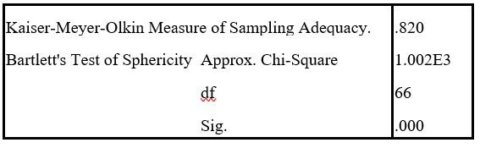
In this case, the KMO value is 0.820, which is considered quite good. Generally, a KMO value above 0.6 is considered acceptable, and higher values indicate a more suitable dataset for factor analysis. Therefore, the obtained KMO value of 0.820 suggests that the dataset is well-suited for factor analysis.
Bartlett's Test of Sphericity assesses whether the correlation matrix is significantly different from the identity matrix, indicating that the variables are correlated. In this instance, the approximate Chi-Square value is 1.002E3 with 66 degrees of freedom, and the associated p-value (Sig.) is
0.000.
A p-value less than the conventional significance level of 0.05 suggests that the variables are significantly correlated. Thus, the result (Sig. .000) indicates that there is a significant relationship among the variables in the dataset, supporting the appropriateness of conducting factor analysis.

Table 2. Communalities
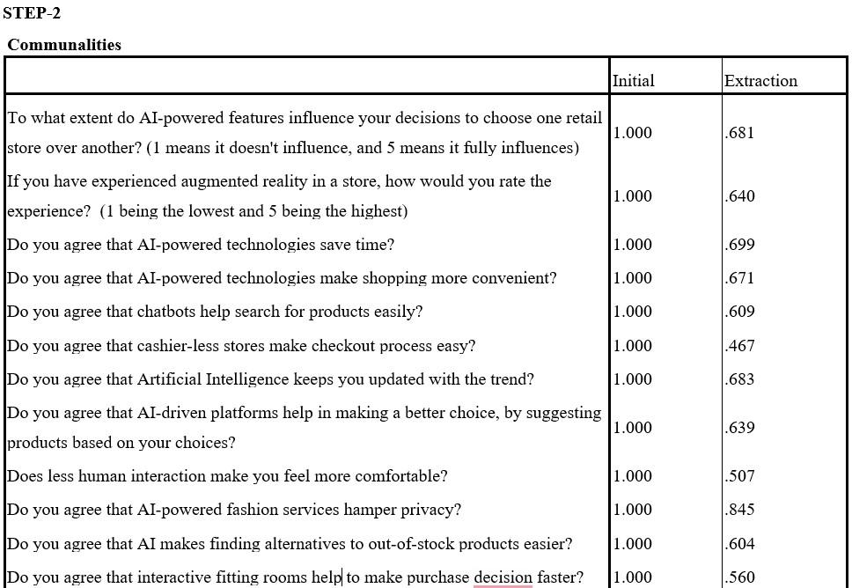
Communalities in factor analysis represent the proportion of the variance in each variable that is accounted for by the common factors. They give insight into how well each variable is explained by the factors extracted during the analysis. Higher communalities (closer to 1.0) indicate that a larger proportion of the variable's variance is explained by the common factors, suggesting that the factor model is a good fit for that variable.

For instance, in the case of the question on the influence of AI-powered features on retail store choices, the factor analysis has successfully explained 68.1% of the variance in participants' responses.
Similarly, for the question about the perceived convenience of AI technologies in saving time during shopping, the factor analysis has captured 69.9% of the variability in opinions.

Notably, some variables, such as the impact of cashier-less stores on the checkout process, exhibit lower communalities, indicating that the factors extracted through PCA explain a smaller proportion (46.7%) of the observed variance in this aspect. In essence, these communalities offer valuable insights into the effectiveness of the factor analysis in capturing and summarizing the underlying patterns within the dataset, making us understand of the relationships among the surveyed variables.

Table 3. Total Variance Explained
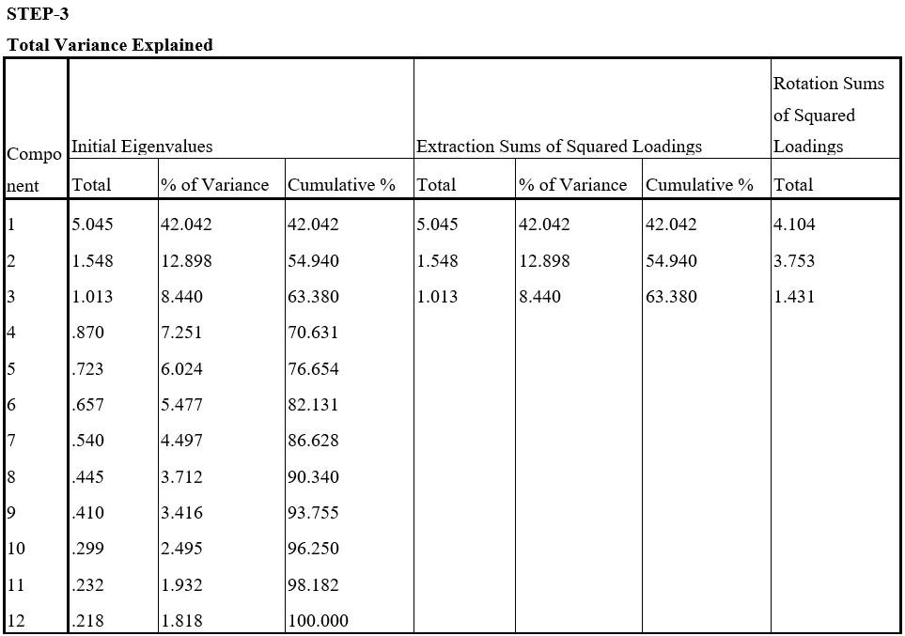
The "Total Variance Explained" table in factor analysis provides information about how much of the total variance in the observed variables is accounted for by the extracted factors. Components that have Total Initial Eigenvalues greater than 1 were considered. In this case, the extracted three components have Total Initial Eigenvalues greater than 1. These three components explain 63.38% of the variance.
In the Pattern Matrix Table the values in each cell indicate the strength and direction of the correlation between a specific question and each component. Notably,

Component 1: This component is strongly associated with questions related to the role of Artificial Intelligence (AI) in keeping users informed about trends (.890), the influence of AI on choices regarding retail stores (.857), and concerns about privacy in AI-powered fashion services. These questions exhibit robust loadings on Component 1.

Component 2: Questions pertaining to attitudes towards AI saving time (.639), the effectiveness of AI-driven platforms in decision-making (.638), and the impact of AI on finding alternatives to out-of-stock products (.389, .498) are notably linked to Component 2. These questions collectively contribute to the definition of Component 2.
Table 4. Pattern Matrix
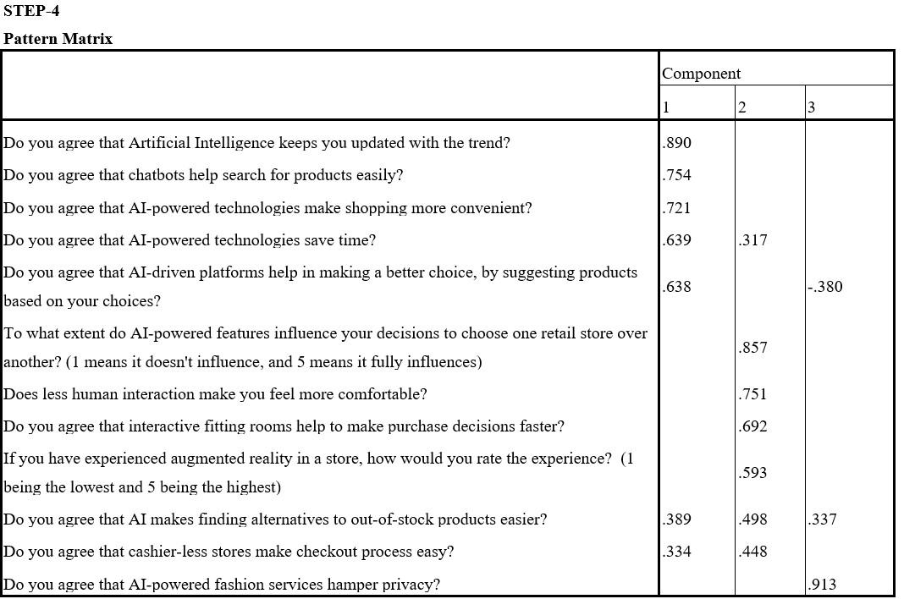
Component 3: Component 3 is characterized by positive loadings for questions concerning comfort levels with reduced human interaction (.721) and the ease of checkout in cashier-less stores (.751, .334). These questions are indicative of the underlying structure and interpretation of Component 3.
Table 5. Extracted Factors
Staying trendy | Time consciousness | Comfort is the key
Role of Artificial Intelligence (AI) in keeping users updated with trends | Attitudes towards AI saving time | Comfort levels with reduced human interaction
The influence of AI on retail store choices | The effectiveness of AI-driven platforms in decision-making | The ease of checkout in cashier-less stores
Concerns about privacy in AI- powered fashion services | Impact of AI on finding alternatives to out-of-stock products

The findings have been summarized in Table 5 which includes the extracted factors.
A correlation coefficient of 1.000 on the diagonal signifies the perfect correlation of each component with itself. Notably, the off-diagonal elements show the correlations between different components. For instance, Component 1 exhibits a positive correlation of .399 with Component 2 and a negative correlation of -.202 with Component 3. Similarly, Component 2 shows a positive correlation of .399 with Component 1 and a negligible correlation of -.031 with Component 3. Component 3, on the other hand, displays a negative correlation of -.202 with Component 1 and a minimal correlation of -.031 with Component 2. These correlation coefficients provide valuable information about the degree of association between the identified components, aiding in the interpretation of the underlying structures and relationships within the dataset.
Table 6 . Component Correlation Matrix
Component | 1 | 2 | 3
1 | 1.000 | .399 | -.202
2 | .399 | 1.000 | -.031
3 | -.202 | -.031 | 1.000

Discriminant analysis
Discriminant analysis is a statistical technique used for various purposes, primarily to differentiate between two or more groups based on a set of predictor variables.
The group statistics table indicates the descriptives related to the selected questions.
Table 7 . Group Statistics
Typeofstore |  | Mean | Std. Deviation | Valid N (listwise)
 |  |  |  | Unweighted | Weighted
Technology  oriented | How important innovative store design | 16.6508 | 2.63003 | 126 | 126.000
 | How important is seamless checkout | 17.2778 | 2.36521 | 126 | 126.000
 | How important human assistant with Tech-Edge | 15.9444 | 2.09115 | 126 | 126.000
Human  oriented | How important innovative store design | 15.0400 | 3.67769 | 75 | 75.000
 | How important is seamless checkout | 14.7733 | 3.29034 | 75 | 75.000
 | How important human assistant with Tech-Edge | 13.8533 | 3.21606 | 75 | 75.000
Total | How important innovative store design | 16.0498 | 3.15238 | 201 | 201.000
 | How important is seamless checkout | 16.3433 | 2.99609 | 201 | 201.000
 | How important human assistant with Tech-Edge | 15.1642 | 2.75462 | 201 | 201.000
For technology-oriented stores, the mean ratings for InnovativeStoreDesign, Seamless Checkout, and HumanAssistantWithTechedge are 16.65, 17.28, and 15.94, respectively.
Human-oriented stores have lower mean ratings for InnovativeStoreDesign (15.04), SeamlessCheckout (14.77), and HumanAssistantWithTechedge (13.85).
These values suggest differences in perceived importance between the two types of stores regarding store design, checkout experience, and human assistance with technology.
Table 8 . Box's Test of Equality of Covariance Matrices
Log Determinants
Typeofstore | Rank | Log Determinant
Technology oriented | 3 | 4.776
Human oriented | 3 | 6.850
Pooled within-groups | 3 | 5.847
The ranks and natural logarithms of determinants printed are those of the group covariance matrices.
The results of Box's Test of Equality of Covariance Matrices, as presented in Table 8, provide important insights into the assumptions of the discriminant analysis. The table displays the ranks and natural logarithms of determinants for the group covariance matrices. This information helps assess the magnitude of the covariance matrices for different groups. The Box's test is significant (Chi-square = 47.092, df = 3, p < 0.001), indicating unequal covariance matrices between groups.
This suggests that the assumption of equal variances among the groups stands rejected.
Table 9 . Wilks' Lambda
Test of Function(s) | Wilks' Lambda | Chi-square | df | Sig.
1 | .788 | 47.092 | 3 | .000

The Wilks' Lambda test is a statistical method used in discriminant analysis to assess the significance of discriminant functions in distinguishing between groups. The output presented in Table 9 provides information about the test results. The Chi-square statistic tests the null hypothesis that the discriminant function(s) do not significantly differ across groups. Higher Chi-square values suggest greater evidence against the null hypothesis.

The Wilks' Lambda test is significant (Chi-square = 47.092, df = 3, p < 0.001), suggesting that at least one discriminant function significantly separates the groups. In practical terms, this implies that there are differences among the groups, and the discriminant functions are effective in distinguishing between them. Researchers or analysts may further explore the discriminant functions to understand the specific variables that contribute to group differentiation.

The standardized canonical discriminant function coefficients in discriminant analysis play a crucial role in understanding the contribution of each variable to the discriminant functions. These coefficients provide insights into the relative importance and direction of influence that each predictor variable has on the discriminant functions.
Table 10 . Standardized Canonical Discriminant Function Coefficients
 | Function
 | 1
Howimportant is innovativestoredesign | .317
Howimportantisseamlesscheckout | .555
HowimportanthumanassistantwithTechEdge | .485
(Constant) | -1.278

With a larger positive coefficient of 0.555, the importance of seamless checkout has a more significant positive impact on the discriminant function compared to innovative store design.
Table 11 . Functions at Group Centroids
Typeofstore | Function
 | 1
Technology oriented | .398
Human oriented | -.669
Unstandardized canonical discriminant functions evaluated at group means

The functions at group centroids in discriminant analysis offer a concise representation of how well the derived discriminant functions separate groups by assigning function values at the centre of each group. The discriminant function for technology-oriented stores (Function 1) has a positive centroid value (0.398), while for human-oriented stores, it's negative (-0.669).
Table 12 . Pooled Within-Groups Matrices
 |  | Innovativestoredesign | Seamlesscheckout | Human assistantwithTechEdge
Correlation | Innovative store design | 1.000 | .247 | .080
 | Seamless checkout | .247 | 1.000 | .456
 | Human assistant with TechEdge | .080 | .456 | 1.000

The correlation matrix shows the relationships between the three variables within the pooled within-groups data. These correlations provide insights into the inter-variable relationships, aiding in the interpretation of the discriminant analysis results.
The discriminant equation provides a practical tool for predicting group membership based on the values of the predictor variables. It allows for the calculation of a discriminant function score, aiding in the classification of individuals into predefined groups.
The discriminant equation usually takes the form:
D=b₁​×Variable₁​+b_{2​}×Variable₂​+…+b_{n}​×Variable_{n​}
D is the discriminant score, b₁,b₂,…,b_{n} are the coefficients, and Variable₁,Variable₂,…,Variable_{n} are the predictor variables.
D = (0.317) Innovativestoredesign + (0.555) Seamlesscheckout + (0.485) Human assistantwithTechEdge -1.278

This discriminant equation can be used to predict group membership or assess the impact of changes in the predictor variables on the discriminant score. For example, higher values in Innovative store design, Seamless checkout, and Human assistant with TechEdge would contribute to a higher D score.

Discussions
The shift from traditional brick-and-mortar stores to e-commerce and omnichannel retailing is evidence of AI's capacity to innovate and stay pertinent in a constantly evolving market. In the conducted research, a significant segment, comprising 37.8%, was identified within the age group of 18-24. Following closely, 32.8% fell within the ages of 25-34, with most respondents mentioning ownership of their own money, indicating financial independence. Notably, 135 out of the total respondents have engaged with AI services in stores.
This research component delves into understanding how people feel and act regarding AI in stores. A majority of 126 respondents out of the total 201 expressed a preference for technology-oriented stores, showcasing a strong inclination toward retail outlets that heavily integrate technological features.
Building on these findings, the introduction of technology-oriented stores is the future, catering to consumers who prioritize time and comfort while still desiring to stay trendy in today's fast-paced life. This initiative involves the incorporation of features such as self-checkouts, scan-and-go, and a custom clothing creation tool. The study's findings suggest a significant population inclination toward using AI tools in stores, particularly with reduced interaction with employees.

Conclusion
In the course of the study, it was observed that a notable proportion, accounting for 37.8%, belongs to the age bracket of 18-24. Following closely, 32.8% fall within the ages of 25-34, with a significant number of respondents indicating financial independence by mentioning ownership of their own money. Out of the total respondents, 135 individuals have engaged with AI services in stores, a pivotal aspect of the research focusing on understanding people's sentiments and behaviour regarding AI in retail environments. A majority, specifically 126 respondents out of 201, have expressed a preference for technology-oriented stores, underscoring a strong inclination toward establishments that heavily integrate technological features. Conversely, 75 respondents have indicated a preference for human-oriented stores, highlighting the importance of traditional, human-centric shopping experiences for this particular segment.

In concluding the research, it is evident that the convenience and comfort associated with AI-powered services vary based on the consumer's age, gender, and location. Consumers in certain locations exhibit a higher comfort level with cashier-less stores and a preference for minimal human interaction, while gender remains an independent variable in this context. Additionally, it can be inferred that consumers across all age groups prefer innovative store designs, which significantly influence their purchasing patterns.

Limitations and Future Studies
The study's duration could be limited, potentially missing long-term trends or the evolution of AI applications in fashion retail beyond the study period. Privacy concerns related to AI in fashion retail may not have been thoroughly examined, representing a potential oversight that could significantly impact consumer behaviour.
The future scope of research on the applications of AI in retail holds immense potential for exploration and advancement. Future research could delve into the evolving role of AI in personalized customer experiences, exploring how AI-driven recommendations and virtual assistants can be enhanced to better cater to individual preferences. Exploring the integration of emerging technologies, such as augmented reality and natural language processing, within AI applications in retail is also an exciting avenue. Overall, the scope for future research on AI in retail is broad and promises to contribute significantly to our comprehension and effective utilization of these transformative technologies.

References:
- Chen, J., & Chang, Y. W. (2023). How smart technology empowers consumers in smart retail stores? The perspective of technology readiness and situational factors. Electronic Markets, 33(1). https://doi.org/10.1007/s12525-023-00635-6
- Chen, J., Song, X., Wang, T., & Zhang, Y. (2019). Retail inventory management with stockout-based substitution and pricing. Omega, 89, 94-109.
- Gazzola, P., Grechi, D., Martinelli, I., & Pezzetti, R. (2022). The Innovation of the Cashierless Store: A Preliminary Analysis in Italy. Sustainability, 14(4), 2034. https://doi.org/10.3390/su14042034
- Lee, J., Kim, J., & Lee, Y. (2021). Chatbot as a new retail assistant: The role of user experience and attitude in its adoption. International Journal of Human-Computer Interaction, 37(3), 245-258.
- Li, X., & Zhang, X. (2018). Consumer privacy concerns and preference for degree of regulatory control. Information Systems Frontiers, 20(3), 585-596.
- Mondol, E. P., Salman, N. A., Rahid, A. O., & Karim, A. M. (2021). The Effects of Visual Merchandising on Consumer’s Willingness to Purchase in the Fashion Retail Stores. International Journal of Academic Research in Business and Social Sciences, 11(7), 386-401.
- Smith, A. N., Wright, R. A., & Dhillon, G. (2020). Artificial intelligence in retail fraud detection: A case study of online retailing. Information Systems Frontiers, 22(1), 113-127.
- Vrhovac, V., Vasić, S., Milisavljević, S., Dudić, B., Štarchoň, P., & Žižakov, M. (2023). Measuring E-Commerce User Experience in the Last-Mile Delivery. Mathematics, 11(6), 1482. https://doi.org/10.3390/math11061482
- Wang, C., & Gunasekaran, A. (2017). A big data analytics approach to supply chain analytics in the hard disk drive industry. International Journal of Production Research, 55(17), 5090-5106.
- Zhang, J., Chang, C.-W., & Neslin, S. (2021). EXPRESS: How Physical Stores Enhance Customer Value: The Importance of Product Inspection Depth. Journal of Marketing, 86, 00222429211012106. https://doi.org/10.1177/00222429211012106

